**Home | Who We Are | Coaching | Work With Us**

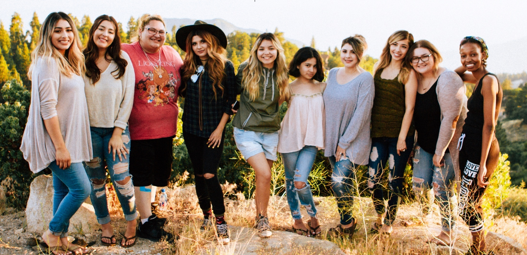

**Living** an Effective Lifestyle Inc. we have discovered how to help individuals and professionals in the small, medium and large organization understand effectiveness in regards to their lives and how they function individually or within a group to improve productivity and sales within an organization from the least to the top personnel.

Our proprietary coaching program that has helped countless individuals like yourself discover their life’s vision, passion, key potentials to living a more effective lifestyle, so they can be happier, be more productive and have a fulfilling life. Providing simple practical tools, the support and as well hold you by the hands to walk you through the process with our Life Coaching Signature Program™.

In most of our trainings, public speaking and seminars we are often asked what our suggestions would be in getting started; one major area we have always suggested is firstly “getting a coach” especially if this is something you’ve struggled with for a while or something you have tried doing with little or no success or even something you have always wanted to do but never had the courage to go for it.



A life coach, for instance, will offer you a professional service where you will be getting Feedback, Insights, and Guidance from an outside vantage point.

The profession of coaching is similar to the practice of a physician, a trainer or psychologist, however, the major difference is that coaching is an On-going, Collaborative Partnership built on “Taking Action”

Let your life coach help you define your dreams, help you recognize what is holding you back, and also help you move forward with great momentum, clarity, and vision.

For more information on how you can discover your key potentials to living a more effective lifestyle, be happier, be more productive and have a fulfilling life simply request our *Free* consultation session or for more information email [info@livinganeffectivelifestyle.com](mailto:info@livinganeffectivelifestyle.com), you’ll be glad you did.

**LEL Inc. | Workshops | Publications | Terms | Resources**

Team Training Programs Newsletter Disclaimer

Contact Us Today’s WORDs in SEASON Privacy Policy

Careers Terms and Conditions

©Copyright 2017. Living an Effective Lifestyle Inc.